**3.1 Empirical Strategy**

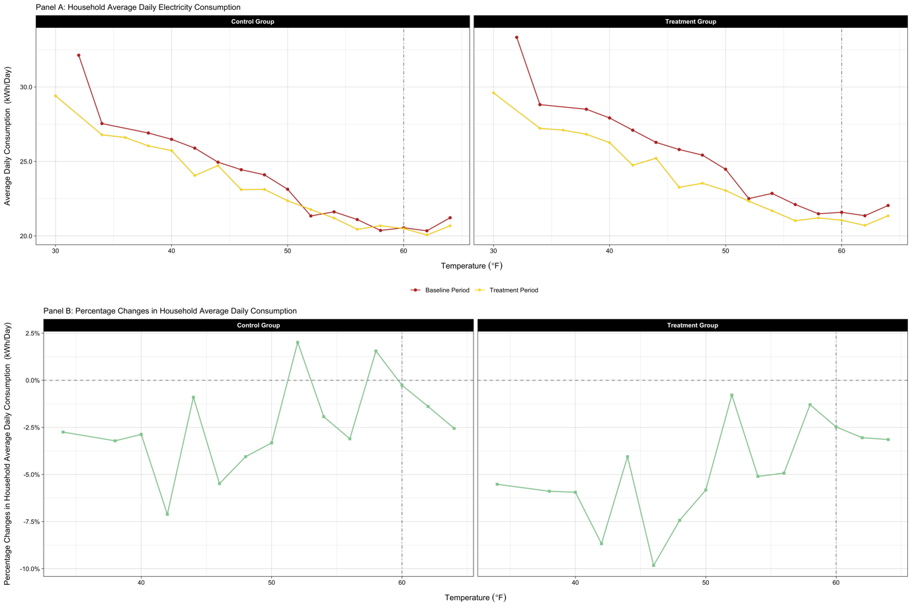

FIGURE, which shows household average daily electricity consumption over temperature and the pre and post differences in the consumption, clearly demonstrates the motivation of this research project.[1] As illustrated in Panel A of the figure, household demand for electricity grew as the temperature decreased. In other words, in addition to temperature-insensitive electricity demand (i.e., for non-temperature-control uses), there was a sizeable demand for electricity for heating (i.e., for temperature-control use) in Irish households, which seems to be highly responsive to temperature variations. In this research, I determine not only how much consumption changes, on average, in response to the time-varying tariffs but also how their impact varies across days with different temperatures. In other words, the dynamic-pricing-causing effects on temperature- and non-temperature-control electricity uses are separately estimated to figure out the primary source of energy savings. As shown in the figure, households in the control group also consumed less electricity during the treatment period, especially on days with low temperatures, although their percentage reduction is smaller than that of the treated households.[2] This suggests the necessity of employing an identification strategy that deals with the before and after differences in electricity consumption of households remained in the traditional tariff structure (i.e., a flat price of 14.1 cents for all hours).

Because the CER experiment dataset primarily utilized in the following empirical analysis was generated from a carefully developed randomized controlled trial (RCT), in principle, the effect of the TOU tariffs on household electricity consumption can be measured simply through the difference in average usage between the two groups during the treatment period.[3] However, due to the non-trivial difference in electricity demand between the control and treatment groups during the baseline period, I follow the previous studies utilizing the same experiment and employ a DID approach to estimate the electricity savings caused by the TOU pricing program.

I include the temperature as an explanatory variable directly in my econometric models. In the previous papers using the identical dataset, fixed-effects (FEs) were utilized to control for time-varying factors that influenced household electricity consumption. Since those studies focused on quantifying how households responded, on average, to the TOU price regimes newly introduced, adding such FEs to their models served their research purpose. In other words, they did not need to explicitly model the relationship between temperature and household electricity consumption to estimate the average treatment effects (ATEs). However, a primary interest of this research is to understand how electricity savings vary with the temperature after shifting to TOU prices. Therefore, more flexible controls rather than FEs, not sweeping out temperature variations across days, are required in my empirical analysis. For that reason, I extend the typical panel DID specification and allow the treatment effect to vary as a function of the daily average temperature.[4] That is, I estimate the ATEs of the dynamic prices on household electricity demand by exploiting the within-household electricity consumption changes across not only periods but temperatures.[5]

**3.2 Average Responses to Time-of-Use Prices**

**3.2.1 Half-Hourly Average Treatment Effects**

Utilizing a panel DID identification strategy, I first measure the impact of the TOU prices on 30-minute-interval household electricity consumption. To obtain the ATE for each half-hour interval, I estimate the following specification:

$${kWh}_{itw} = β_{w}{I[Treatment \& Post]}_{it} + α_{iw} + γ_{dw}+ δ_{m} + ε_{itw}$$

The term ${kWh}_{itw}$ is the electricity consumption by household *i* on the day *t* during the half-hourly time window *w*. The indicator variable ${I[Treatment \& Post]}_{it}$ is equal to one only if household *i* is in the treatment group and the day *t* is in the treatment period. The terms $α_{iw}$, $γ_{dw}$, and $δ_{m}$ are household-by-half-hourly-interval, day-of-week-by-half-hourly-time-window, and month-of-year fixed effects, respectively. In the specification, the point estimates of $β_{w}$ representing the ATE for each 30-minute interval *w* are the parameters of interest. I cluster the standard errors at the household and the day of experiment levels to correct for serial correlation.

FIGURE summarizes the estimated ATEs in the form of a time profile. As also demonstrated in Prest (2019), the time profile shows dominant electricity savings during peak hours (i.e., from 5:00 p.m. to 7:00 p.m.). The result indicates that the TOU tariffs served their purpose to resolve the peak demand problem. In the following empirical analysis, I continually focus on household electricity demand responses to the time-varying prices during the peak rate period.

**3.2.2 Average Treatment Effects in the Peak Rate Period**

It is worth estimating peak-rate-period ATEs relative to the control group to comprehend how the responsiveness of Irish households to TOU electricity pricing varied with the magnitude of price changes.[6] To do so, I run the following regression for each of the four tariff groups:

$${kWh}_{ith} = β_{p}{I[Treatment \& Post]}_{it} + α_{iw} + γ_{dw}+ δ_{m} + ε_{itw}$$

Excepting the dependent variable and the parameters of interest, the econometric model above is the same as (MODEL1). Specifically, the response variable ${kWh}_{ith}$ means the electricity consumption by household *i* on the day *t* during the hour of the day *h*, and the point estimates of $β_{p}$ indicate the ATE for each of three rate periods *p*. TABLE summarizes the regression results.

The results demonstrated in TABLE indicate that the measured ATEs generally follow the law of demand: in general, the reduction in household demand for electricity during the peak rate period grows with the size of the price jump. Importantly, the results imply that household electricity savings from temperature-control use or ones from non-temperature-control uses depend on the amount of the tariff change in the peak rate period. Motivated by this implication, the relative responsiveness of the two distinct drivers of energy savings to the time-varying prices introduced is quantified below.

**3.3 Breakdown of Peak-Rate-Period Household Responses to Time-Of-Use Prices**

**3.3.1 Breakdown of Household Responses in the Peak Rate Period**

I decompose the TOU-tariff-causing reductions in electricity consumption during the peak rate period into two parts to determine the share of energy savings stemming from two different sources: savings from temperature-control and non-temperature-control uses. Isolating the impact of TOU prices on household electricity demand for temperature-control use from the total reductions in electricity demand enables us to know how differently the TOU tariff structures function from day to day. Generally, retail electricity rates under a TOU price scheme only have by-time-of-day variations. So, each day has the same within-day evolution of electricity prices. The effectiveness of the TOU pricing, however, can alter across days if its impact on temperature-sensitive energy use is not negligible because temperatures highly fluctuate every day. In other words, the time-varying pricing, whose primary purpose is to address the peak demand problem, works well, especially on days having a more significant gap between retail electricity prices and the marginal cost of supplying electricity under a flat rate electricity plan (e.g., days with extreme temperatures), if the responsiveness of the temperature-control electricity use to the dynamic price is large enough.

To break down peak-hours household responses to TOU prices, I exploit the following econometric model inspired by the DID framework:

$${kWh}_{ith} = {β_{1}HDD}_{t} + β_{2}{I[Treatment]}_{i} + β_{3}{HDD}_{t}{I[Treatment]}_{i} + β_{4}{I[Post]}_{t} + β_{5}{HDD}_{t}{I[Post]}_{t} + β_{6}{I[Treatment \& Post]}_{it} + β_{7}{HDD}_{t}{I[Treatment \& Post]}_{it} + α_{dw} + γ_{mw}+ ε_{ith}$$

Like (MODEL-2), the dependent variable ${kWh}_{ith}$ is the electricity consumption by household *i* on the day *t* during the hour of the day *h*. There are three indicator variables in the model: the first indicator variable ${I[Treatment]}_{i}$ has the value of 1 if household *i* is assigned to the treatment group; the second indicator variable ${I[Post]}_{t}$ equals 1 when the day *t* is in the treatment period; the last indicator variable ${I[Treatment \& Post]}_{it}$ is equal to 1 only for treatment households during the treatment period. The model also includes interaction terms between daily HDDs and those indicator variables. The terms $α_{dw}$ and $γ_{mw}$ are day-of-week-by-half-hourly-time-window and month-of-year-by-half-hourly-time-window fixed effects, respectively.

The primary coefficients of interest in (MODEL-3) are $β_{6}$ and $β_{7}$. Both coefficients show how much electricity consumption households have reduced since the deployment of the TOU tariffs. To be specific, $β_{6}$ is the decrease in household electricity consumption for non-temperature-control uses, while $β_{7}$ is associated with the reductions in electricity consumed to satisfy household heating needs for given HDDs.

Using the points estimates of the two coefficients of interest presented in TABLE below, I show how the electricity savings caused by the TOU prices vary with daily HDDs in FIGURE.[7] As clearly illustrated, the households assigned to the treatment group significantly reduced their electricity consumption when they were subject to the TOU prices. In addition, it is evident from the figure that the share of temperature-control-use-related demand reductions grows as household electricity needs for heating become serious. For example, the energy savings originating from electricity consumption for temperature-control use are close to half of the TOU-pricing-inducing reductions in household electricity demand when Irish household needs for heating are at their peak (i.e., around daily HDDs of 30).

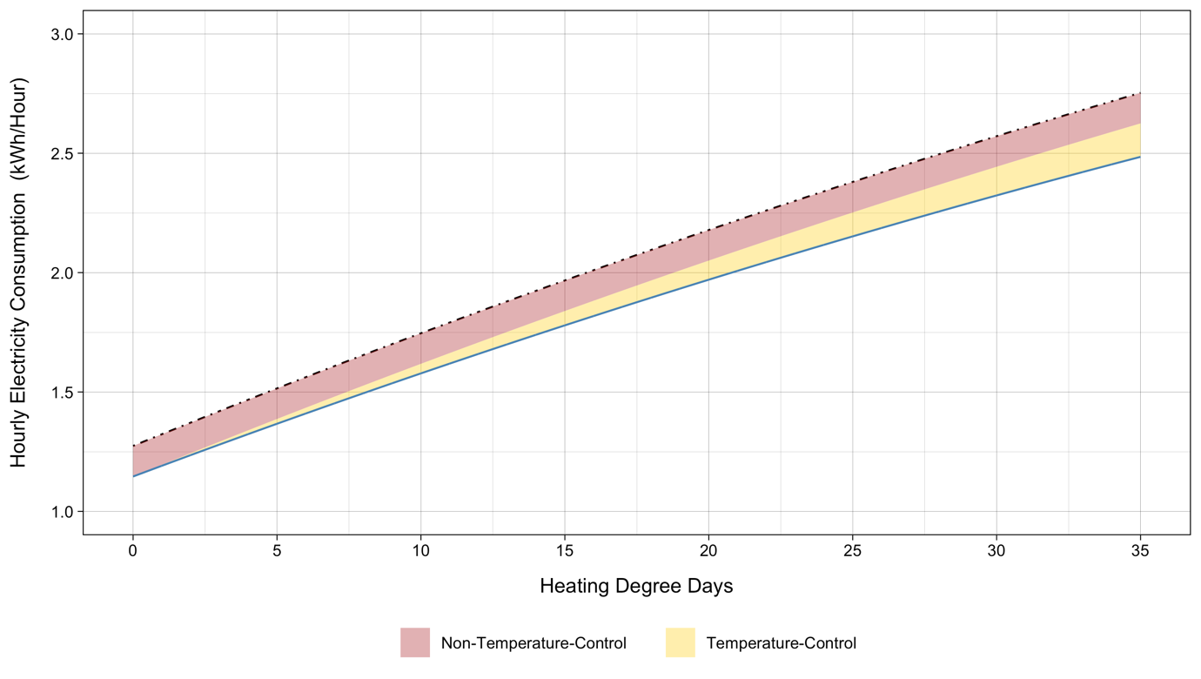

**3.3.2 Peak-Rate-Period Household Responses as a Linear Function of Price Changes**

(…)

**4 (…)**

1. An important feature also stands out from the figure: the minimum household electricity consumption occurs around 60 degrees of Fahrenheit. This phenomenon supports the setting of the reference temperature for calculating daily HDDs at the very level.
2. In Panel A, non-treated households consumed more electricity during the baseline period, especially on days with higher heating needs. The fact that the total HDDs during the baseline period were generally greater than those during the treatment period for a given temperature bin could explain the phenomenon.
3. Because random assignment of participating households puts selection bias right, observed differences in electricity consumption between the control and treatment groups after introducing the TOU tariffs are only attributable to their differences in exposure to the time-varying electricity prices.
4. Under three identifying assumptions, applying the DID strategy to measure energy savings obtained from adopting the TOU prices makes sense. First, the parallel trend assumption is required for the DID estimator. Considering that the 30-minute interval meter reads for participating households were collected from a trial, the assumption means that the pre-treatment-period load profile for the treated households should be very similar to that for the non-treated households. FIGURE A showing average within-day load profiles for the two groups during the baseline period supports the plausibility of the parallel trend assumption. In addition, the electricity consumption profile for the control group illustrated in FIGURE B, which smoothly evolved over the entire experiment period although heavily fluctuated day to day, suggests its high reliability as a counterfactual under the assumption.

   The second identifying assumption necessary for the plausibility of the identification strategy employed is the assumption of common temporal shocks. This assumption implies that a treatment-status-irrelevant unexpected event occurring at the same time as or following the deployment of the dynamic prices should have the same impact on both the control and treatment groups. Although the common shocks assumption cannot be tested directly, the similar trends in electricity demand profiles for the control and treatment groups shown in FIGURE B support the assumption required for the DID approach.

   Third, the stable unit treatment value assumption (SUTVA) must hold too. The SUTVA requires that introducing TOU prices did not affect the electricity consumption of the untreated households. That is, the SUTVA allows no spillovers. During the recruitment process, the locational distribution of the participating households was aligned with that of the total Irish population to construct a representative sample of the national population. Because only a few thousand households scattered geospatially participated in the nationwide experiment, it is unlikely that the treated households influenced the households allocated to the control group. This again supports the SUTVA required under the DID identification strategy.
5. The attrition rate during the RCT was about 20%. The main reasons for participant attrition were changes in tenancy and supplier. Due to the imperfect compliance, the estimates must be interpreted as local average treatment effects (LATEs). However, according to CER (2011), attrition was unlikely to be associated with the RCT. Furthermore, the level of attrition varied only marginally across treatment status.
6. In this paper, the effects of four different information stimuli on household electricity consumption are not of interest. Pon (2017) studied the effects in detail using the same datasets.
7. The first column in TABLE shows the result from the regression above.